1

**Project Documentation**

Project Title:insight stream-navigate the news landscape

**1. Introduction**

1. **Project Title:**insight stream-navigate the news landscape
2. **Team ID:** NM2025TMID41067
3. **Team Leader: Name:Jayamoorthy T**  &mail id:jayamoorthytamilselvan@gmail.com
   1. Team Members: Name:Jegadeesh V & Mail id :vjegadeesh101@gmail.com
   2. Name:Kamalesh L & mail id:kamaleshniranjan5@gmail.com
   3. Name:Karthik S & mail id:s.karthick666666@gmail.com

**2. Project Overview**

* 1. **Purpose:**  The purpose of the "Insight Stream: Navigate the News Landscape" project is to develop a platform that enables users to efficiently navigate and make sense of the vast and diverse news landscape. The platform aims to provide a streamlined way for users to discover, analyze, and stay informed about news topics that matter to them.
  2. **Features**: The platform could include the following featured components:
  3. 1. Personalized News Feed: A customized feed that allows users to view news articles based on their interests and preferences.
  4. 2. Topic Hubs: Dedicated sections for specific topics, such as politics, technology, or entertainment.
  5. 3. Sentiment Analysis: A feature that analyzes news sentiment and provides users with insights.
  6. 4. News Trends: A section that highlights trending news stories and topics.
  7. 5. Real-time Notifications: Push notifications that alert users to breaking news and updates

**3. Architecture**

The architecture of Insight Stream would involve a combination of frontend and backend components to provide a seamless user experience

**4. Setup Instructions**

* 1. Prerequisites:
  2. 1. Node.js: Ensure Node.js is installed on your system.
  3. 2. npm or yarn: Ensure you have a package manager installed (npm or yarn).
  4. 3. MongoDB: Ensure MongoDB is installed and running on your system.
  5. Setup Steps1. Clone the Repository: Clone the Insight Stream repository from GitHub using git clone https://github.com/username/insight-stream.git
  6. 2. Install Dependencies: Run npm install or yarn install to install the required dependencies.
  7. 3. Configure Environment Variables: Create a .env file and configure environment variables such as MONGO_URI, NEWS_API_KEY, etc.
  8. 4. Start the Application: Run npm start or yarn start to start the application.

**5. Folder Structure**

TJ-Works/

├── client/

│ ├── public/

│ │ ├── index.html

│ │ └── favicon.ico

│ └── src/

│ ├── components/

│ │ ├── NewsFeed.js

│ │ └── NewsCard.js

│ ├── containers/

│ │ └── App.js

│ ├── api/

│ │ └── newsApi.js

│ └── utils/

│ └── helpers.js

├── server/

│ ├── models/

│ │ └── News.js

│ ├── controllers/

│ │ └── newsController.js

│ ├── routes/

│ │ └── newsRoutes.js

│ └── utils/

│ └── auth.js

├── config/

│ └── database.js

├── tests/

│ ├── client/

│ │ └── NewsFeed.test.js

│ └── server/

│ └── newsController.test.js

├── package.json

└── README.md

**6. Running the Application**

1. Frontend:
2. 1. Node.js: Ensure Node.js is installed on your system.
3. 2. npm or yarn: Ensure you have a package manager installed (npm or yarn).
4. 3. MongoDB: Ensure MongoDB is installed and running on your system.
5. Steps to Run the Application1. Navigate to the Project Directory: Open a terminal and navigate to the InsightStream project directory.
6. 2. Install Dependencies: Run npm install or yarn install to install the required dependencies.
7. 3. Start the Backend Server: Run npm run server or yarn server to start the backend server.
8. 4. Start the Frontend Development Server: Run npm run client or yarn client to start the frontend development server.
9. 5. Access the Application: Open a web browser and navigate to http://localhost:3000 to access the InsightStream application.

**7. API Documentation**

* 1. User: The API responses will be in JSON format, with the following structure:
  2. {
  3. "data": {},
  4. "error": null,
  5. "message": ""
  6. }
  7. Error Handling
  8. The API will return error responses in the following format:
  9. {
  10. "error": {
  11. "code": 404,
  12. "message": "Not Found"
  13. }
  14. }
  15. **8. Authentication**

The API uses authentication tokens to secure endpoints. Clients must provide a valid token in the Authorization header.

**9. User Interface**

1. Landing Page
2. Freelancer Dashboard
3. Admin Panel
4. Project Details Page

**10. Testing**

Testing is crucial to ensure the quality and reliability of the InsightStream application. A comprehensive testing strategy includes unit tests, integration tests, and end-to-end tests.

**11. Screenshots or Demo**

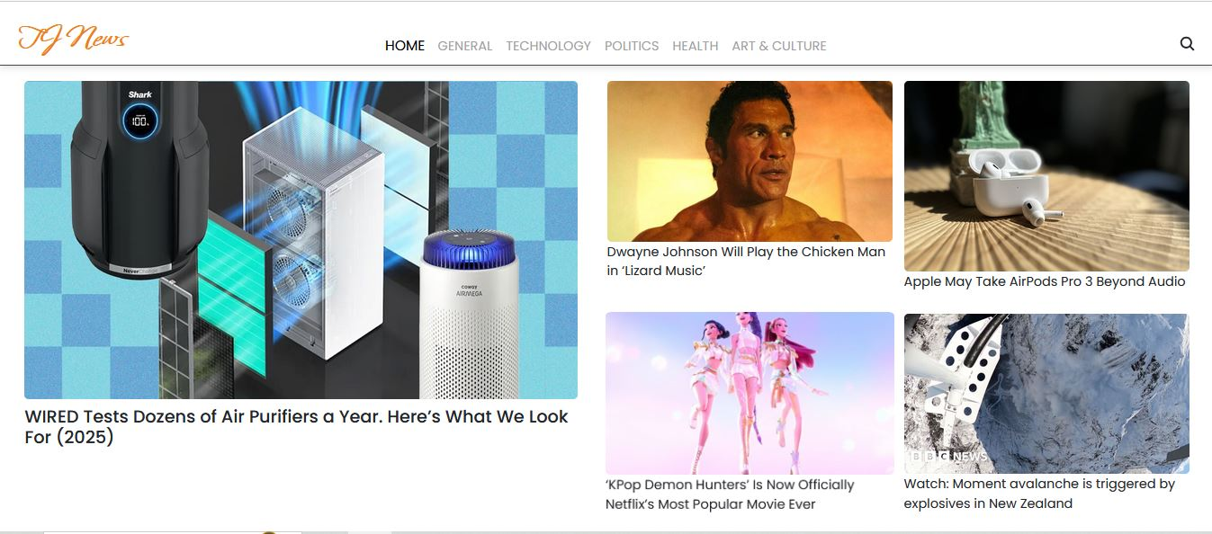

**This is the Home Page**

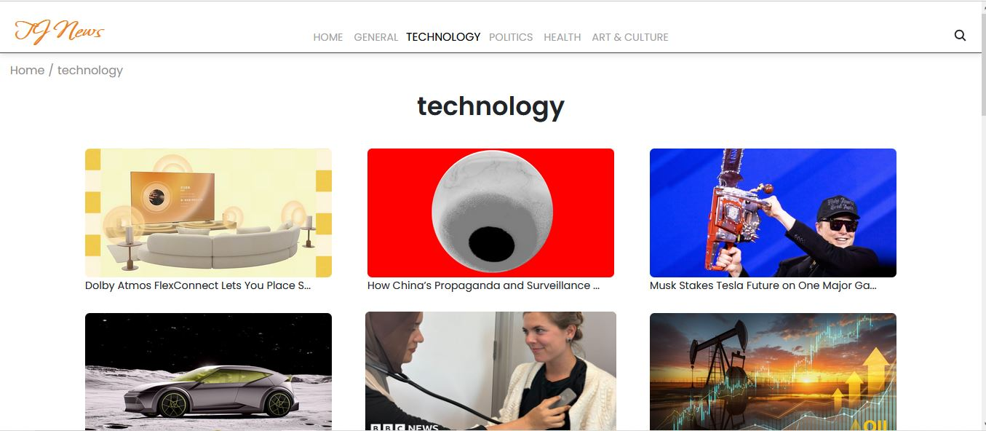

**This is the Technology Section.**

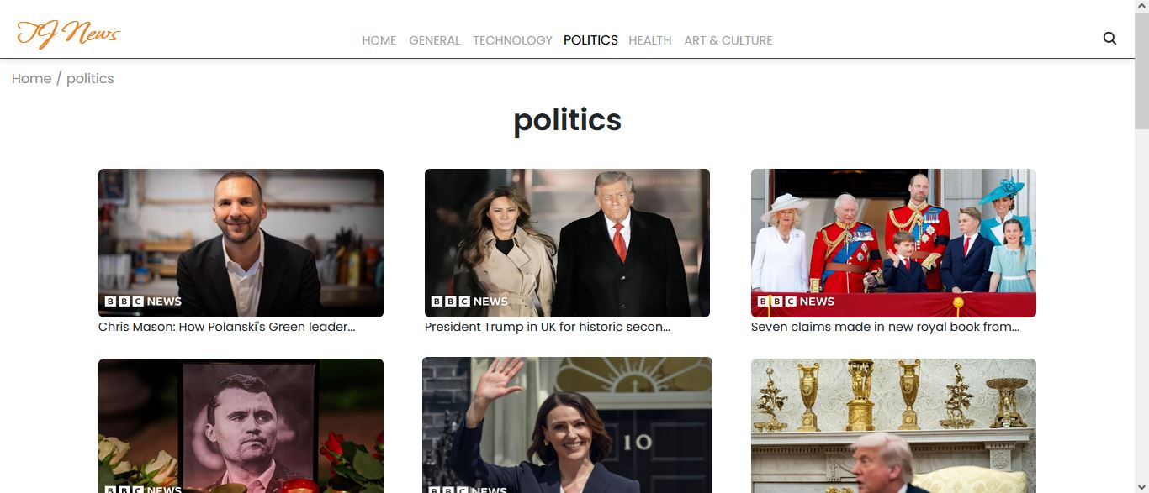

**Politics Page**

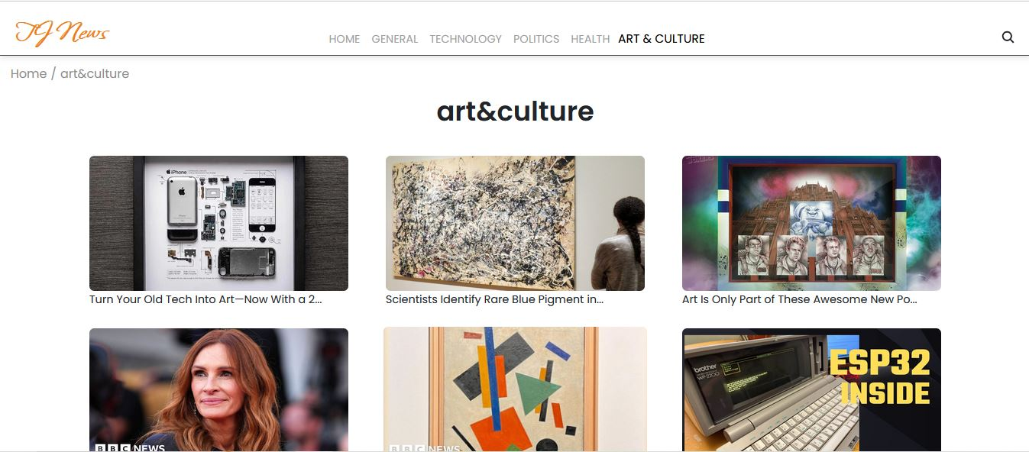

This is the Art and Culture Section.

**Demo Video Link :**

**https://drive.google.com/file/d/1mTv-SeibMc-eWO_ios2zijvXRomipcrw/view?usp=drive_link**

**12. Known Issues**

**There are lack of images and loading sites.**

**13. Future Enhancements object Documentation**

**We should add more real time news and images.**

**And we should add more web pages.**